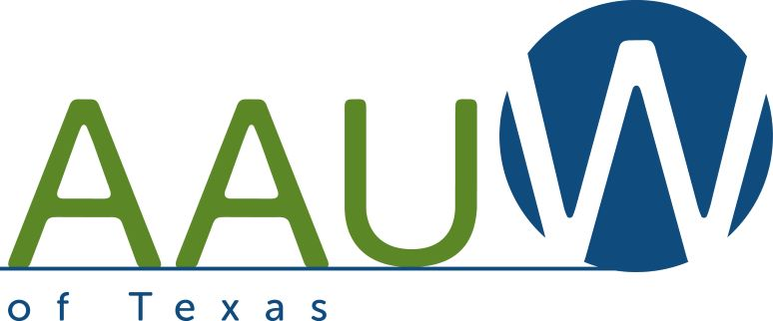
APPLICATION FOR A STUDENT NCCWSL GRANT

Application to AAUW San Antonio, Inc. to attend AAUW’s National Conference for College Women Student Leaders (NCCWSL)’s in-person premier leadership conference on May 31-June 3, 2023.
This application is due to AAUW San Antonio: March 24, 2023 for Early Bird pre-registration.
- Selection will be on a first come/first served basis; please send your application to the AAUW web site quickly since we have a limited number of scholarships.
- A refundable $50 fee to the grant application will be required. The fee will be held and returned to the student after the recipient submits a paragraph about their conference experiences for publication in the AAUW SA newsletter. The student must send $50 to Karen Reichensperger, Scholarship chair, 4310 Mill Bend, SA 78217.
Applicants will be notified of their selection by the deadline. AAUW San Antonio will register the student and pay the full early bird resident registration fee. The fee covers room and board. Additional funds will be sent to the recipient for air fare and taxi.

By submitting this application for a NCCWSL grant, applicants understand that they will attend AAUW’s NCCWSL event.
Student Signature: ____________________________________ Date: _________
Printed Signature: ____________________________________
Student email address: ____________________________________
Alternate Student email address: ____________________________________
Student mailing address: ____________________________________
Student telephone number: _____________________ Ethnicity ______________
College: ____________________________________
Degree sought: ____________________
Anticipated Year of Graduation: ________________
Send this application to: aauw.sanantonio@gmail.com

